Presentation:

<https://www.canva.com/design/DAFTUIYlRw8/pJEwY5h_8E1yCDfUy8W68w/view?utm_content=DAFTUIYlRw8&utm_campaign=designshare&utm_medium=link2&utm_source=sharebutton>

Email [oskar.zahharov@outlook.com](mailto:oskar.zahharov@outlook.com) if link does not work.

Do’s:

* Black screen look left right, safety measures next to busy sections
* see when and where your friends are playing to get you to go outside
* Make the children run around
* partnership GGD (givecards for points earned?)

Don’ts:

* Chat, adding friends without being in close proximity

Games:

* Single player:
* Tic tac toe (AI)
* Chess (AI)
* battleship (AI)
* rock paper scissors (AI)
* treasure hunt
* easter eggs
* find the animal
* 4conect (AI)
* Labyrinth
* Scrabble (AI)
* Trivia crack (AI)
* With friends:
* Floor is lava
* tic tac toe
* chess
* tag
* battleship
* rock paper scissor
* red light green light
* 4connect
* Mens erger je niet
* Scrabble
* Funky hopscotch (Squid game) Bakugan

Safe small sidetasks on the route from playground B to playground A. For instance if there is a monument on the way something related to it. Imagination is the ceiling, it is just crucial to have the “sidetasks” in safe environments and not by busy intersections or other dangerous places.

Side quest, not at playgrounds. Interactive art, connect it with “Ken je stad”.

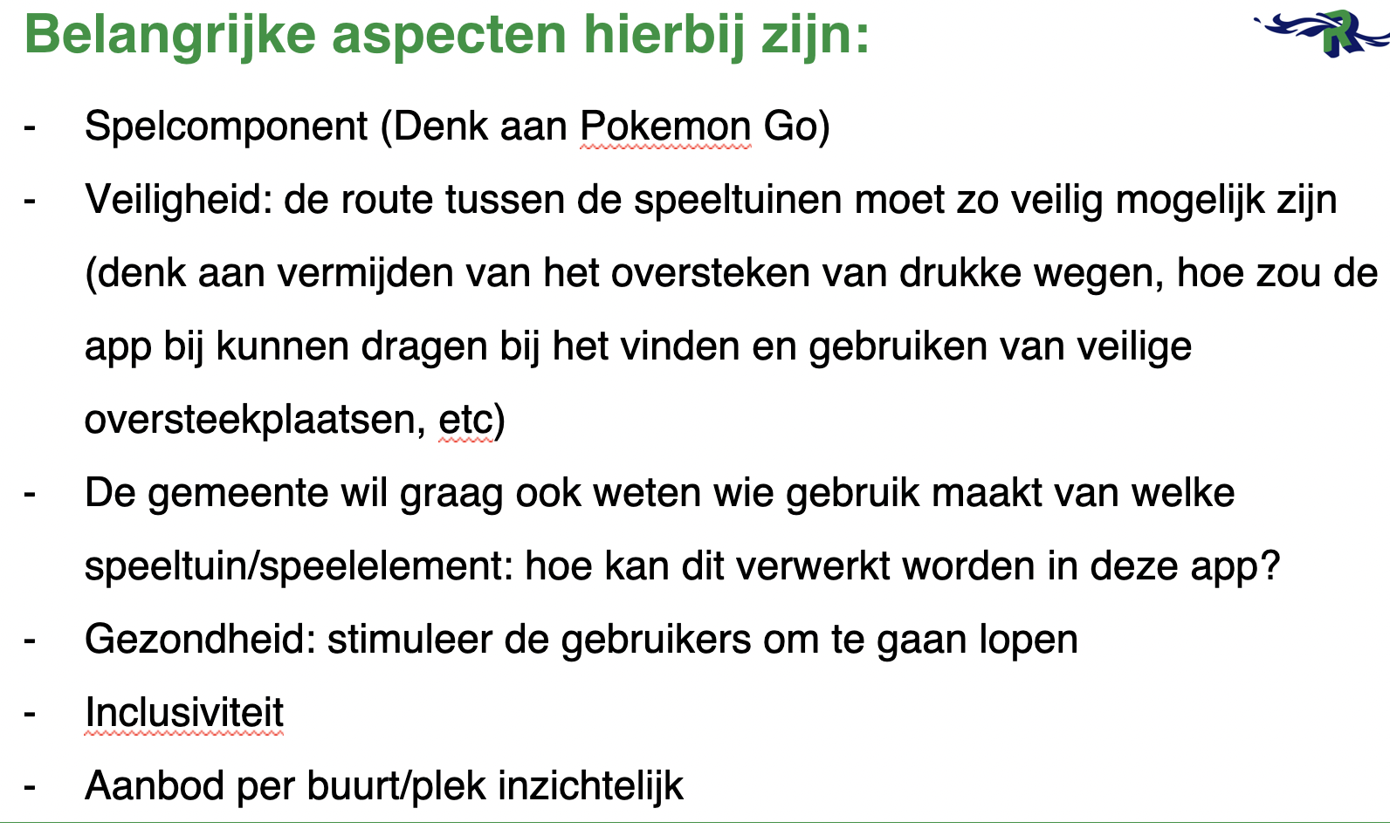

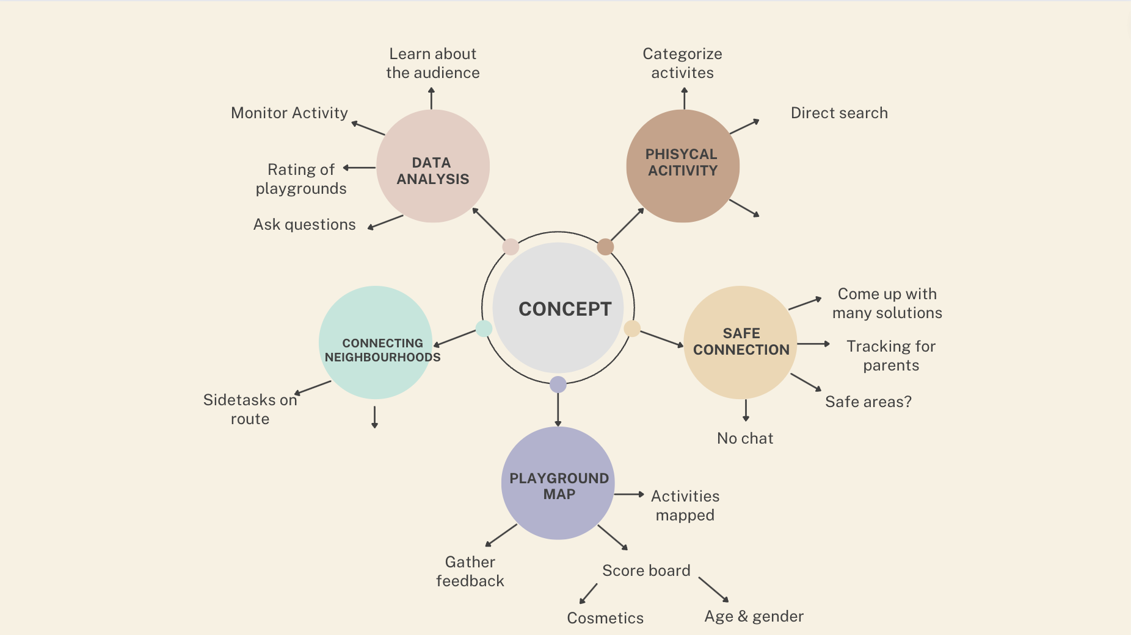

<https://onlinelibrary.wiley.com/doi/full/10.1111/tesg.12505>

research on outdoor play and perceived effects

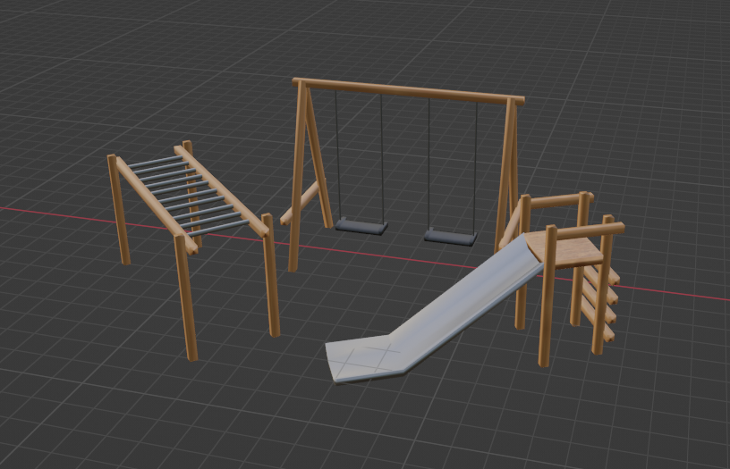

/\ 3D models to show on map as seen below in the ui design

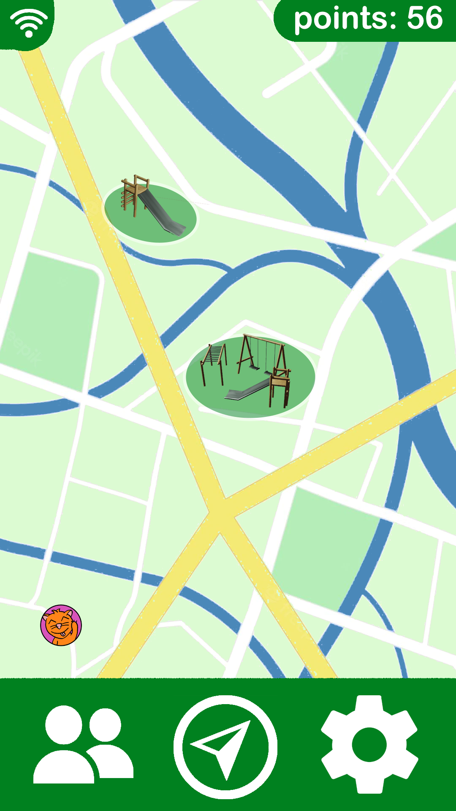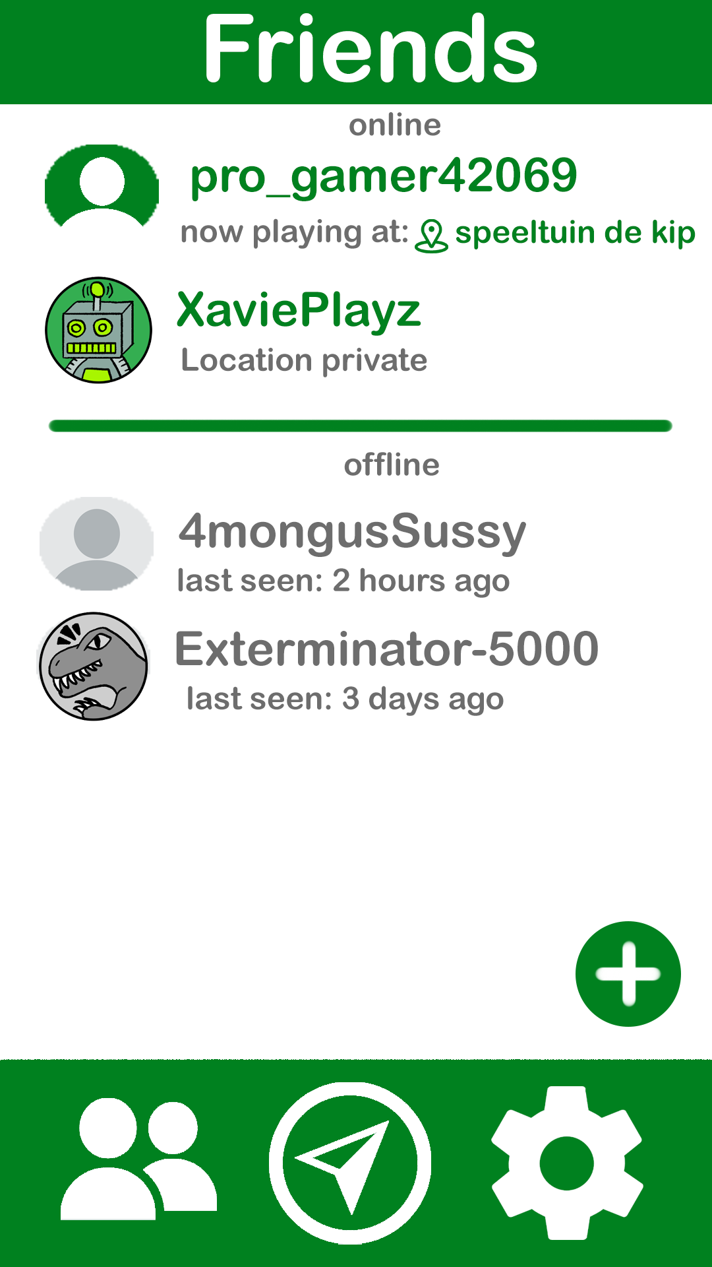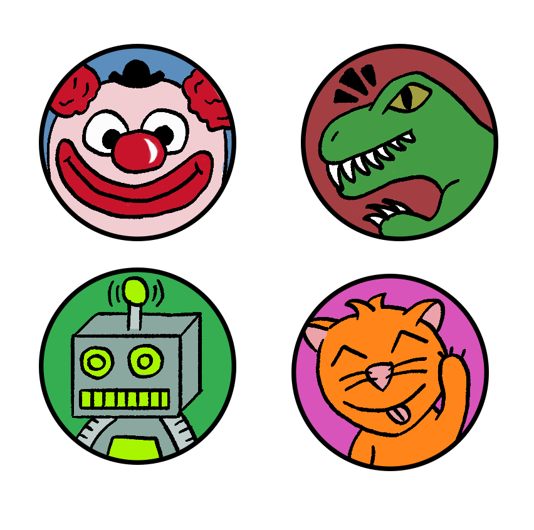

we used bright colors to appeal to a younger audience, mostly green to symbolize the outside world and nature, white and green also are the city colors of rotterdam. colorful avatars and icons instead of text to make the app easy and fun for children

Safe Travel:

Use reinforcement learning algorithm based on traffic data (google earth also uses reinforcement learning). Base idea of how the reinforcement learning works; areas with a lot of traffic give less points than areas with less traffic. A shorter route gives more points than a longer route. The algorithm will optimize the route to get as many points as possible, which, in the end will be the route with the best combination of being short and with minimal traffic. Things to keep in mind with this, are there areas that you don’t want kids to go to, and maybe prioritize normal walkways over allays.